**PAF changed to 100-190 range.**

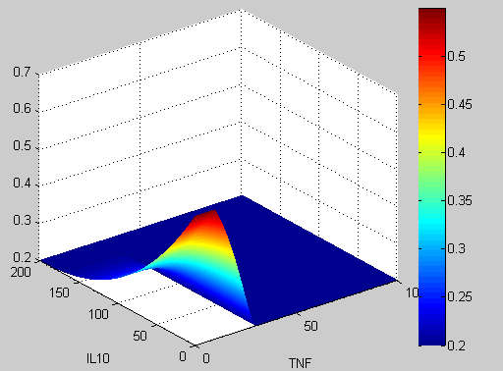

**PAF changed to 100-190 range rotated.**